**Ceramic Menorah Kit Components:**

* The Menorah base is a 3” x 12” x ¼” thick ceramic tile.
  + One piece
* The candles rest on a ¾” round x ¼” thick ceramic tile.
  + Eight pieces
* The Shamash candle rests on a stack of three (3) – ¾” round x ¼” thick ceramic tiles that will be glued together.
  + Three pieces
* The metal candle holders will be glued on the top of the nine (9) candle round ceramic bases.
  + Nine metal candle holders
* The felt pads will be applied to the bottom of the base to protect the table from scratches.
  + Four pieces
* The Menorah kit assembly instruction guide.
  + One printed Menorah Kit assembly instruction sheet
* Package:
  + The menorah ceramic base will be bubble wrapped along with the round ceramic tiles and the metal candle holders. (No candles included)
  + The assembly will be placed into a labeled poly bag with the instruction sheet and sealed.

**Assembly:**

* The eight (8) ¾” round ceramic tiles are glued to the Menorah Base. (Glue not included. We recommend Gorilla Glue. Elmer’s Glue will not hold properly.)
* The Shamash base will be assembled with three (3) of the glued ¾” round ceramic tiles and will be positioned in the center of the Menorah base. Alternatively, the Shamash may be positioned at one end or the other.
* The nine (9) metal candle holder are glued in the center of the nine (9) round ¾” ceramic tiles.

**Decoration:**

* The Ceramic Menorah can be decorated with Sharpie brand colored permanent markers or with acrylic paint. (Markers and paint not included.)

The views of the Menorah are the Top View and the Side View shown below.

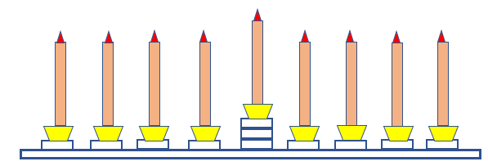

Photo of the assembled HPCT-CAE Ceramic Make-A-Menorah 2.0 Kit:

