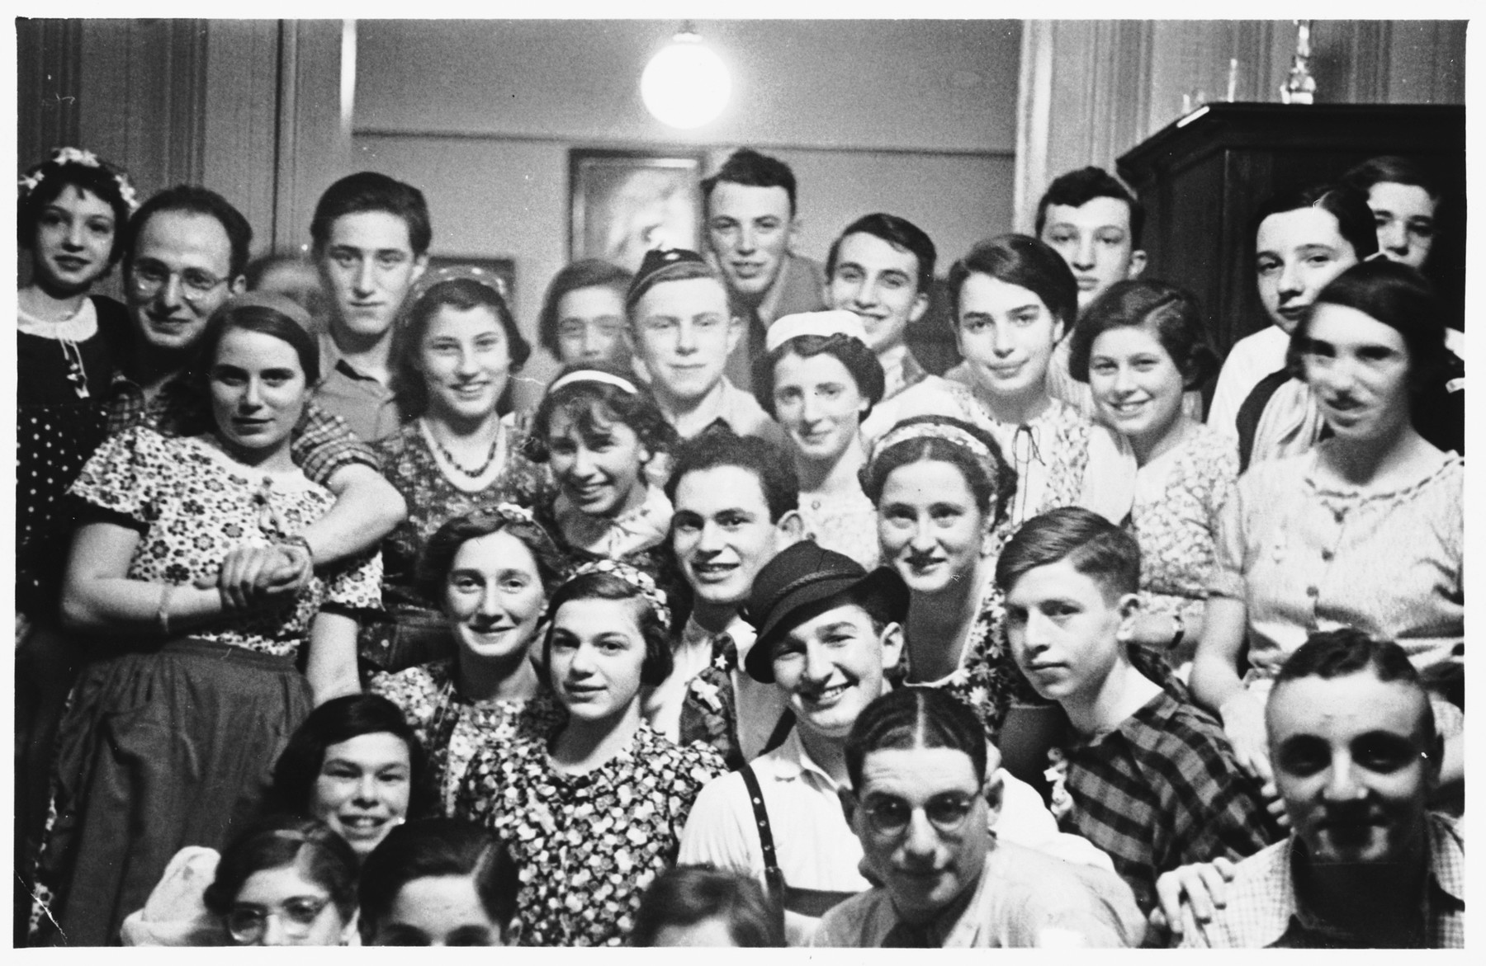

**Ghettos**

* http://accountsoftheholocaust.org/accountsoftheholocaust/media/Avatars/female-icon.png?ext=.pngFAY LEWIN

We were first moved into a ghetto in Zhuprany for about 6 months and then we were moved to a bigger ghetto in nearby Ashmiany.  The ghetto had a toilet outside. 50 people lived in one room and we were there for about a month and a half. The Jews of Zhuprany (including my father, grandparents, brother, and other family) were next taken by truck to the Mielegjany forced labor camp in Lithuania, near Kovnas. Then we were taken to the first concentration camp, where we were building roads and a railroad. We were given horse meat to eat.  Our goal was to work hard and hope not to get beaten.

* http://accountsoftheholocaust.org/accountsoftheholocaust/media/Avatars/robert-katz.jpg?ext=.jpgROBERT KATZ (New York, United States)

*I remember reading about ghettos being created in Warsaw and I assume in other cities too. What was life really like in the ghetto during the war?*  
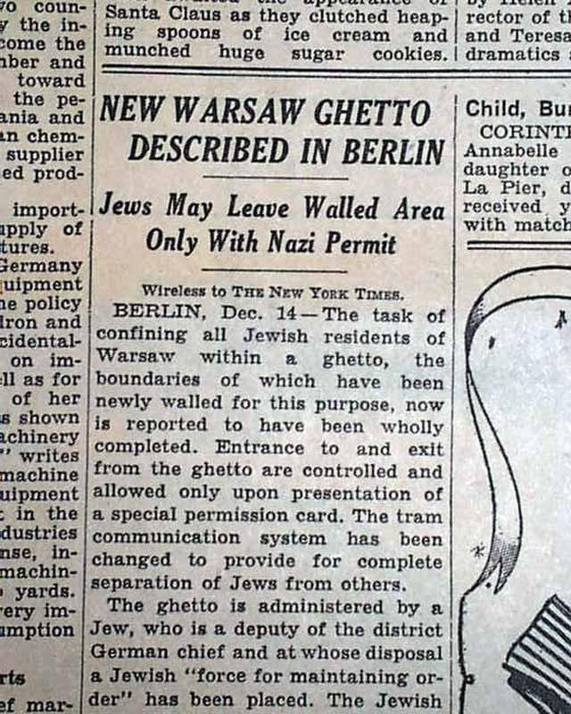

http://accountsoftheholocaust.org/accountsoftheholocaust/media/Avatars/irene-klass.png?ext=.pngIRENE KLASS (Warsaw Ghetto)

The signs were hung on the street saying that the ghetto is going to be formed in Warsaw and we had two weeks to move to the ghetto.  

http://accountsoftheholocaust.org/accountsoftheholocaust/media/Avatars/israel-gurwicz.jpg?ext=.jpgISRAEL GURWICZ (Vilna Ghetto)

We had the best of everything, so many special items that belonged to us; like beautiful furniture, paintings, crystal glassware, and Persian carpets. But we could only take what we could carry to the ghetto, maybe one or two suitcases.

http://accountsoftheholocaust.org/accountsoftheholocaust/media/Avatars/elana-kutorgiene.jpg?ext=.jpgELANA KUTORGIENE

I looked out the window and saw a long wagon driving by. Amid the pathetic looking tables, chairs and mattresses that were piled up… along the street in single file – walked Jews with yellow stars on their backs.

http://accountsoftheholocaust.org/accountsoftheholocaust/media/Avatars/irene-klass.png?ext=.pngIRENE KLASS

Now my father did not move to the ghetto with us. My father managed straight away to get false papers and he lived on the Christian side under false papers.  My father didn’t look Semitic so he could get away with it.  Where my mother did look Semitic and we felt that we had to go to the ghetto.  We were given one very tiny room.  We were allocated a room in the ghetto for my mother, myself, my grandmother and my uncle.

* http://accountsoftheholocaust.org/accountsoftheholocaust/media/Avatars/janina-dawidowicz.jpg?ext=.jpgJANINA DAWIDOWICZ (Warsaw Ghetto)

Walls were being built in various places all around us. Then we realized we were in a trap. It was incredibly crowded; you had to push your way through.

http://accountsoftheholocaust.org/accountsoftheholocaust/media/Avatars/ella-blumenthal.jpg?ext=.jpgELLA BLUMENTHAL (Warsaw Ghetto)

When we came into the ghetto, there was turmoil, confusion, panic and fear. There was malnutrition, starvation, epidemics. Little children starving in rags were begging in the streets.

http://accountsoftheholocaust.org/accountsoftheholocaust/media/Avatars/henry-greenblatt.jpg?ext=.jpgHENRY GREENBLATT (Warsaw Ghetto)

The ghetto was a designated area and there was a gate that the people could come in and go out showing certain documents and I remember my father used to come to the Polish policeman and he would show him his identification as an invalid and the policeman would kind of feel sorry for him. My father would pull out his glass eye and kind of look pretty bad and the policeman would let us out… We would go the market to buy some food and we would bring the food in without any problems. That continued for a few weeks. Then they closed up the Ghetto and no one was allowed to get out. No adult could take a chance to get out.

http://accountsoftheholocaust.org/accountsoftheholocaust/media/Avatars/robert-katz.jpg?ext=.jpgROBERT KATZ

*And were there ghettos in other East or Central European cities?*

http://accountsoftheholocaust.org/accountsoftheholocaust/media/Avatars/robert-katz.jpg?ext=.jpgROBERT KATZ

*You mention Polish policemen at the gate to the ghetto but who was keeping control inside?*

http://accountsoftheholocaust.org/accountsoftheholocaust/media/Avatars/eliezer-breslin.jpg?ext=.jpgELIEZER BRESLIN

The Judenrat was responsible for carrying out all orders received from the Germans… The Judenrat was also responsible for handing out rations of bread to all the Jewish members of the ghetto according to portions of 120 grams of bread for each soul. It was also responsible for sending Jewish workers to carry out labour in places where the Germans needed them and also for reporting any persons missing from the ghetto to the Germans.

http://accountsoftheholocaust.org/accountsoftheholocaust/media/Avatars/robert-katz.jpg?ext=.jpgROBERT KATZ

*I have heard some people accuse the Judenrat of helping the Nazi – is this true?*

http://accountsoftheholocaust.org/accountsoftheholocaust/media/Avatars/eliezer-breslin.jpg?ext=.jpgELIEZER BRESLIN (Mir, Belarus)

 I was elected to the Judenrat… The Judenrat was also smuggling messages they received… to the Jews in the surrounding villages to forewarn them the Germans were about to exterminate the Jews in the villages, the Judenrat was forewarning the Jews, telling them to leave their homes before they were found.

http://accountsoftheholocaust.org/accountsoftheholocaust/media/Avatars/teofila-silberring.jpg?ext=.jpgTEOFILA SILBERRING (Podgorze Ghetto, Krakow)

We still had our things when we went into the ghetto, and there they allocated one room to three to four families, divided by wardrobes. I slept behind one wardrobe, along with Father and my brother, another family slept behind another wardrobe, and well, that's how we lived. 

http://accountsoftheholocaust.org/accountsoftheholocaust/media/Avatars/Anna-Liebener.jpg?ext=.jpgANNA LIEBNER

*There were no ghettos in Berlin - we were transported to Lodz in Poland… I just remember the hunger*

http://accountsoftheholocaust.org/accountsoftheholocaust/media/Avatars/shimon-srebnik.jpg?ext=.jpgSHIMON SREBNIK (Lodz Ghetto)

We got a loaf of bread for 8 days. But people finished it in 2 days, and then what? I walked around with a stick with a nail stuck on the end. A truck with potatoes passed outside the ghetto. I ran after the truck and caught potatoes with my stick, and came home with food for lunch. We were thieves.

http://accountsoftheholocaust.org/accountsoftheholocaust/media/Avatars/janina-dawidowicz.jpg?ext=.jpgJANINA DAWIDOWICZ (Warsaw Ghetto)

There was an incredible amount of beggars. First they were standing, then they were sitting on the pavement, then, eventually lying down, and then they were dead. When you came out in the morning, you found dead bodies lying on the street, you just stepped over them and walked on.

http://accountsoftheholocaust.org/accountsoftheholocaust/media/Avatars/teofila-silberring.jpg?ext=.jpgTEOFILA SILBERRING (Podgorze Ghetto, Krakow)

Father used to procure the food from somewhere. I don't know whether he still had money or sold things; he didn't let me in on the secret.

http://accountsoftheholocaust.org/accountsoftheholocaust/media/Avatars/Anna-Liebener.jpg?ext=.jpgANNA LIEBNER

*Maybe he bought food from one of the smugglers?*

http://accountsoftheholocaust.org/accountsoftheholocaust/media/Avatars/robert-katz.jpg?ext=.jpgROBERT KATZ

*Smugglers? There were people able to bring extra food into the ghettos – how?*

http://accountsoftheholocaust.org/accountsoftheholocaust/media/Avatars/ella-blumenthal.jpg?ext=.jpgELLA BLUMENTHAL (Warsaw Ghetto)

There were Jewish people who brought in food. There were smugglers.  There were also little children who took to smuggling and through little holes in the wall in the ghetto they brought in food but they were often caught and shot and you could see the little bodies hanging over the wall or a pool of blood on the ground… 

http://accountsoftheholocaust.org/accountsoftheholocaust/media/Avatars/henry-greenblatt.jpg?ext=.jpgHENRY GREENBLATT (Warsaw Ghetto)

They built a high wall, probably about 10 feet tall, with glass on top so you could not scale the wall. On the other hand they left a little bit of a hole by the gutter for the water to run through… It was a small hole but for me, as a little kid, it was enough for me to crawl through. All the kids would crawl through not knowing what happens on the other side… I would go out from the ghetto, I would buy food but I couldn’t carry too much. I would buy one bread, sometimes some potatoes and a little bit of different things that were pretty cheap, not to spend too much money and bring it into the ghetto. My father would sell it and we have a little bit left over. 

* http://accountsoftheholocaust.org/accountsoftheholocaust/media/Avatars/robert-katz.jpg?ext=.jpgROBERT KATZ

*It sounds like you spent most of your days being preoccupied with food and how to get more? Did work and school not carry on?*

http://accountsoftheholocaust.org/accountsoftheholocaust/media/Avatars/teofila-silberring.jpg?ext=.jpgTEOFILA SILBERRING (Podgorze Ghetto, Krakow)

In the ghetto Father worked in the hospital. I don't know what he did there - he had had nothing to do with medicine, of course, but they took him, because he was wise. He went to work in the mornings. I stayed at home; my brother worked too. He used to go somewhere with Father; I don't even remember…

http://accountsoftheholocaust.org/accountsoftheholocaust/media/Avatars/irene-klass.png?ext=.pngIRENE KLASS (Warsaw Ghetto)

Now my mother managed to arrange with a teacher in the ghetto for me to have lessons and there were about five or six children in the group and we used to go every morning to a certain flat and be taught the basics.

http://accountsoftheholocaust.org/accountsoftheholocaust/media/Avatars/helen-fagin.png?ext=.pngHELEN FAGIN (Radomsko Ghetto)

We would try to establish a semblance of a social life, semblance of an intellectual life. For example there were no schools and my younger sister was very young and I knew that she needed education, so I established a clandestine school and the girls would come to my room… and I would conduct classes with them. I would spill out of my head whatever I remembered having learned in my school and the most incongruous subject matter, I would teach them Latin vocabulary, I would teach them geography, I would teach them anything I knew… One of the things that I read most recently, prior to establishing this school, was the Polish translation of “Gone with the Wind “ and when the girls came and they were so solemn and they were so sorrowful and they would say – please tell us a story and I would say: “ok today I am going to take you to a totally different world” and I took them to a Southern plantation in Georgia. And I was talking to them about Melanie and Scarlet and Bret Butler and their eyes would open and they would dream about it… So we would be dreaming together

http://accountsoftheholocaust.org/accountsoftheholocaust/media/Avatars/zdenka-fantlova.png?ext=.pngZDENKA FANTLOVA (Terezín)

Amongst all the population, especially from Czechoslovakia, were original artists, professional artists: conductors,  musicians, soloists, actors, writers. They all came in and  said “Since we are here, shouldn’t we do something… This is terribly important and it will not be entertainment – we need to create!” The human nature – if people are incarcerated they want to express themselves. 

http://accountsoftheholocaust.org/accountsoftheholocaust/media/Avatars/robert-katz.jpg?ext=.jpgROBERT KATZ

*But how were you able to express yourselves and really did it make a difference considering the terrible conditions that people have described on this page?*

http://accountsoftheholocaust.org/accountsoftheholocaust/media/Avatars/ela-weissberger.png?ext=.pngELA WEISSBERGER

 When we were singing, we forgot all our troubles… it was possible to have hope.

http://accountsoftheholocaust.org/accountsoftheholocaust/media/Avatars/robert-katz.jpg?ext=.jpgROBERT KATZ

*I still don’t really get it… and I don’t mean to offend anyone here but I really want to understand… how did singing make a difference to your lives in Theresienstadt?*

http://accountsoftheholocaust.org/accountsoftheholocaust/media/Avatars/ela-weissberger.png?ext=.pngELA WEISSBERGER

We were happy and so were the audience. We all wanted to completely exhaust that moment of freedom. When we were onstage it was the only time we were allowed to remove our yellow stars.

http://accountsoftheholocaust.org/accountsoftheholocaust/media/Avatars/robert-katz.jpg?ext=.jpgROBERT KATZ

*And what did the Germans think about all this?*

http://accountsoftheholocaust.org/accountsoftheholocaust/media/Avatars/zdenka-fantlova.png?ext=.pngZDENKA FANTLOVA (Theresienstadt)

The Germans had nothing against it… People started immediately building a stage, wooden benches and so on… There were people who were composers and they took the opportunity and wanted to create new music to express their feeling of the place and the situation… and the result was that the people who came to a concert or a play in that place, suddenly felt [like] human beings. 

http://accountsoftheholocaust.org/accountsoftheholocaust/media/Avatars/robert-katz.jpg?ext=.jpgROBERT KATZ

*So all that was allowed?*

http://accountsoftheholocaust.org/accountsoftheholocaust/media/Avatars/zdenka-fantlova.png?ext=.pngZDENKA FANTLOVA (Theresienstadt)

But of course what we didn’t know is what the Germans knew; that we were sentenced to death, sooner or later.

* http://accountsoftheholocaust.org/accountsoftheholocaust/media/Avatars/robert-katz.jpg?ext=.jpgROBERT KATZ

*I remember hearing about Theresienstadt, I’m sure I heard it described as a “spa town”? I realize that it might have been “beautified” a little for the Red Cross visit in June 1944 and the cameras but I heard people could still have a good life there. Is there someone who can tell me what it was really like?*

http://accountsoftheholocaust.org/accountsoftheholocaust/media/Avatars/helga-weiss.jpg?ext=.jpgHELGA WEISS

Part of Terezín [Theresienstadt] was prepared like a stage. The old ones and the ill ones were sent away… They used this stage for a film… but it is a lie, propaganda film created by Germans. We were not allowed to go outside to see the Red Cross. The Germans chose a group of young people and gave them a basket with vegetables, and they had to walk along and sing. It was all a stage, a performance, a humbug.

http://accountsoftheholocaust.org/accountsoftheholocaust/media/Avatars/edith-sheldon.jpg?ext=.jpgEDITH SHELDON

It was called city beautification... because the ghetto was overcrowded the first thing they did was send about one third of the people east to Auschwitz… They painted the houses, the footpath had to be scrubbed, they made a coffee shop there where people had to sit and drink this horrible coffee.

http://accountsoftheholocaust.org/accountsoftheholocaust/media/Avatars/gerty-skalsky.jpg?ext=.jpgGERTY SKALSKY

When they invited the Red Cross to come, they [the Nazis] assembled a jazz orchestra to show the Red Cross that we live a normal life there. 

http://accountsoftheholocaust.org/accountsoftheholocaust/media/Avatars/judy-nachum.jpg?ext=.jpgJUDY NACHUM

Most of the people in that camp, one way or the other, knew German and they tried desperately to point out to the Red Cross that they should go away from that main street and they should ask to go into a side street and have a look. And they never did… The film came out… and the Red Cross signed that they saw and that it was exactly what they saw.

http://accountsoftheholocaust.org/accountsoftheholocaust/media/Avatars/robert-katz.jpg?ext=.jpgROBERT KATZ

*But did the Germans at least leave you alone in the ghettos?*

http://accountsoftheholocaust.org/accountsoftheholocaust/media/Avatars/irene-klass.png?ext=.pngIRENE KLASS (Warsaw Ghetto)

We were told that if there was knock on the door or if we hear somebody coming, we must quickly hide the books and put them under the bed because Jewish children are not allowed to learn.

http://accountsoftheholocaust.org/accountsoftheholocaust/media/Avatars/irena-veisaite.jpg?ext=.jpgIRENA VEISAITE (LITHUANIA)

In some ways it was a relief to go to the ghetto... because we felt really insecure and unprotected in the town.. but this was also, not a secure place.

* http://accountsoftheholocaust.org/accountsoftheholocaust/media/Avatars/rabbi-menashe-levertov.jpg?ext=.jpgRABBI MENASHE LEVERTOV

The religious life in the ghetto did not change.  Orthodox Jews in their deep faith did not deviate one step from the centuries old Tradition. There were a few small synagogues in which prayers were held three times daily.  Ritual was observed as in normal times and in the hardest moments the religious Jews did not neglect the religious practices.  In almost every home Kaddish was said.  In the hardest days, during anniversaries of the tragic events, fast days were proclaimed.

http://accountsoftheholocaust.org/accountsoftheholocaust/media/Avatars/robert-katz.jpg?ext=.jpgROBERT KATZ

*And the Germans allowed you to carry on with these meetings and rituals?*

http://accountsoftheholocaust.org/accountsoftheholocaust/media/Avatars/rabbi-menashe-levertov.jpg?ext=.jpgRABBI MENASHE LEVERTOV

Fasts were officially forbidden as the Germans considered them to be a symbol of rebellion and protest, the days of fasts were announced in the small synagogues.  Afterwards, the news was transmitted by word of mouth and so the remaining [alive] honored the memory of the murdered until they themselves fell victim to further murders.

* http://accountsoftheholocaust.org/accountsoftheholocaust/media/Avatars/annie-bleiberg.jpg?ext=.jpgANNIE BLEIBERG (Lubaczow Ghetto, Poland)

We didn’t go out much, we were afraid… I mean there was a curfew, but even during the day, men didn’t go out.

http://accountsoftheholocaust.org/accountsoftheholocaust/media/Avatars/robert-katz.jpg?ext=.jpgROBERT KATZ

*Why? What could happen?*

http://accountsoftheholocaust.org/accountsoftheholocaust/media/Avatars/israel-gurwicz.jpg?ext=.jpgISRAEL GURWICZ

The greatest danger to our already temporary existence in the ghetto was another sudden Aktions. Again the SS Death Squad with their Lithuanian allies were in the ghetto and started rounding up innocent men, women, elderly and children in the thousands for up to 5 days at a time. The lorries were going to Ponary and making 3 return trips a day. This had taken out any hope and confidence of survival.

http://accountsoftheholocaust.org/accountsoftheholocaust/media/Avatars/ella-blumenthal.jpg?ext=.jpgELLA BLUMENTHAL (Warsaw Ghetto)

People were caught in the street to work and were offered bread and jam if they would report voluntarily to work, but when these people did not return, we realised that there was something wrong.  People stopped reporting and then there were new tactics.  Blocks were cordoned off in the ghetto and whoever was there was caught, but before the raid started you could just hear… "they're catching", "they're catching" and people tried to run upstairs or into courtyards because they wanted to try and save themselves.

http://accountsoftheholocaust.org/accountsoftheholocaust/media/Avatars/esther-kerner.jpg?ext=.jpgESTHER KERNER (Nadworna Ghetto, Previously Poland, now in the Ukraine)

We spoke about suicide and I brought from the pharmacy some special things that I could give to my parents and to me as we had discussed. My father became very religious in the ghetto and said no – you shouldn’t kill yourself, that is one of the greatest sins and he wouldn’t take anything and he wouldn’t let me take it.