**GROUP PHOTO**

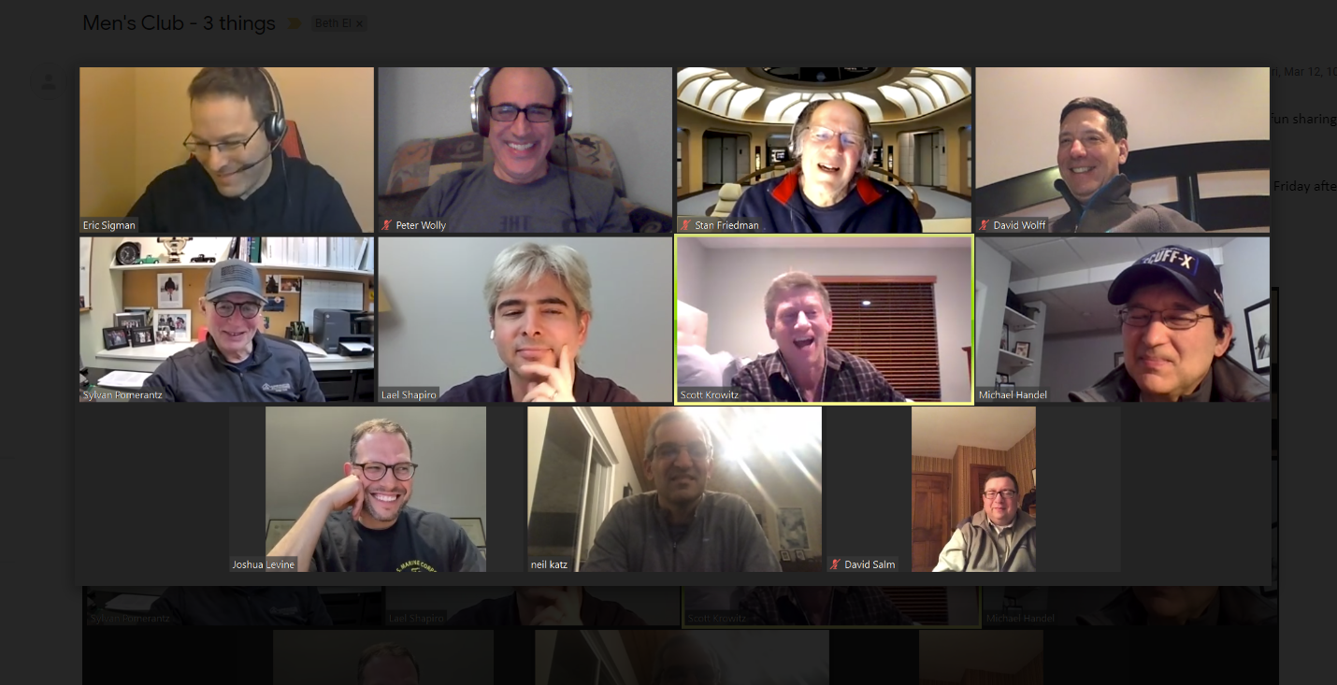

**SURVEY (Reach out to Stan for results)**

Josh, here’s my take on a survey. Questions are in the order to be asked. I can do a SurveyMonkey if you want. I would not make it anonymous. We’re not asking for anything that’s confidential or controversial. BTW, I removed Israel and Politics from your topic list since we want issues that can be discussed from the standpoint of personal experience and feelings. - Stan

1. How would you rate the HMV session? (5-point scale from poor to excellent)
2. Is 7:30 pm – 8:30 pm a good time to hold these sessions? (Yes/Should be earlier/Should be later)
3. How likely are you to attend an HMV session again? (5-point scale from very unlikely to definitely)
4. Can we count on you to invite other TBE men to attend? (yes/no)
5. Based on your experience at the first session:
   1. What is the maximum number of participants, including the facilitator, that should be together in a room? (6, 7, 8, 9, 10, 11)
   2. What is the minimum number, including a facilitator? (4, 5,6)
6. Here are some general topic areas for future HMVs. Select those that appeal to you.
   1. Body and Spirit: Staying healthy and fit
   2. From Hebrew School to the Present: defining your Jewish identity, in search of God, the role of religion in your life
   3. Work and Worth: The role of work in your life, juggling work/life balance, defining success
   4. Me vs. We: How should we interpret today’s divided county and world? Are we islands unto ourselves or do we have a collective responsibility to our fellows?
   5. Family: Aging parents, fathers and sons, fathering a daughter
   6. Other
7. Additional comments and suggestions (open-ended)

**NOTES**

**AGENDA**

* Introduction of HMV and moderators (Josh) - 5 min
* [Norms](https://app.box.com/s/9ytw9oyd9nnmun4omi4fmxryf1z5n6w2) (Eric) - 2 min

Be kInd to yourself

* Share your voice

Be kInd to others

* Be respectful of everyone’s time and share relevant stories.
* Be respectful of everyone’s voice
* During virtual, camera on, mute when not speaking and appropriate naming
* Do not gossip about what transpires with HMV
* Be on time
* Do not interrupt
* Actively listen with empathy
* Introduction to topic (Eric) - 2 min

With the advent of the pandemic, men have had to simultaneously work from home, help their wives, participate in their children's daily care and education, and provide assistance for elder or disabled family members. For many men, this upheaval in their pre-COVID routines and responsibilities has often been overwhelming and frustrating, fueled by the anxiety over the virus itself. At this session, we'll discuss both the rewards and challenges that these new dynamics have created for each of us.

* Breakout Rooms - 40 min (6 to 8 people including moderator)

How has your life changed due to Covid? What accomplishments/challenges have

you faced within your family?

Has it been for the better or worse?

How has your relationship with your family members changed?

* + - Your spouse?
    - Your child(ren) living at home?
    - Parents?
    - Immediate family living close by or far away?

What are the things you’ve enjoyed/missed most of all when it comes to family?

What are your greatest concerns/accomplishments regarding you personally and your family moving forward?

* + - Changed work environment
    - Your children’s education
    - Continued fear of virus transmission
* Closing (Josh) - 10 min
  + - Feedback
    - Involvement - planning topics or moderation

**INTRO**

Hi. I’d like to send out the following communication to TBE men announcement HMV. Comments, please. Also need the title of the initial session. Thanks. – Stan

*Subject: A Special Program for TBE Men Only: Hearing Men’s Voices*

*The TBE Men's Club is announcing an exciting new program for its members called Hearing Men's Voices (HMV). Developed by the Federation of Jewish Men's Club, the male volunteer arm of the Conservative movement, the program has been adopted by synagogue Men's Clubs across the U.S. and Canada.*

*HMV facilitates intimacy among men through rich and enjoyable dialog. Men meet in small groups to openly discuss common issues; their roles as fathers, sons and husbands; and how they find meaning within an ever-changing religious and secular world. Its purpose is to provide men with new insights gleaned from others' personal experiences and self-reflection.*

*Our inaugural HMV session will be held via Zoom on Thursday, March 11, at 7:30 pm. The topic will be "XXXXXXXX." Please mark the date on your calendar. Registration information will be sent out next week.*

*Topics under consideration for future sessions include: Our Fathers, Ourselves; Talking to Aging Parents; Body and Spirit: Men Staying Healthy and Fit; Work and Worth; Men in Search of God.*

*We look forward to seeing you on March 11.*