**Appendix B**

**Men’s Club Screenshots and Links**

**Men’s Club Access from the CBS Home Page**

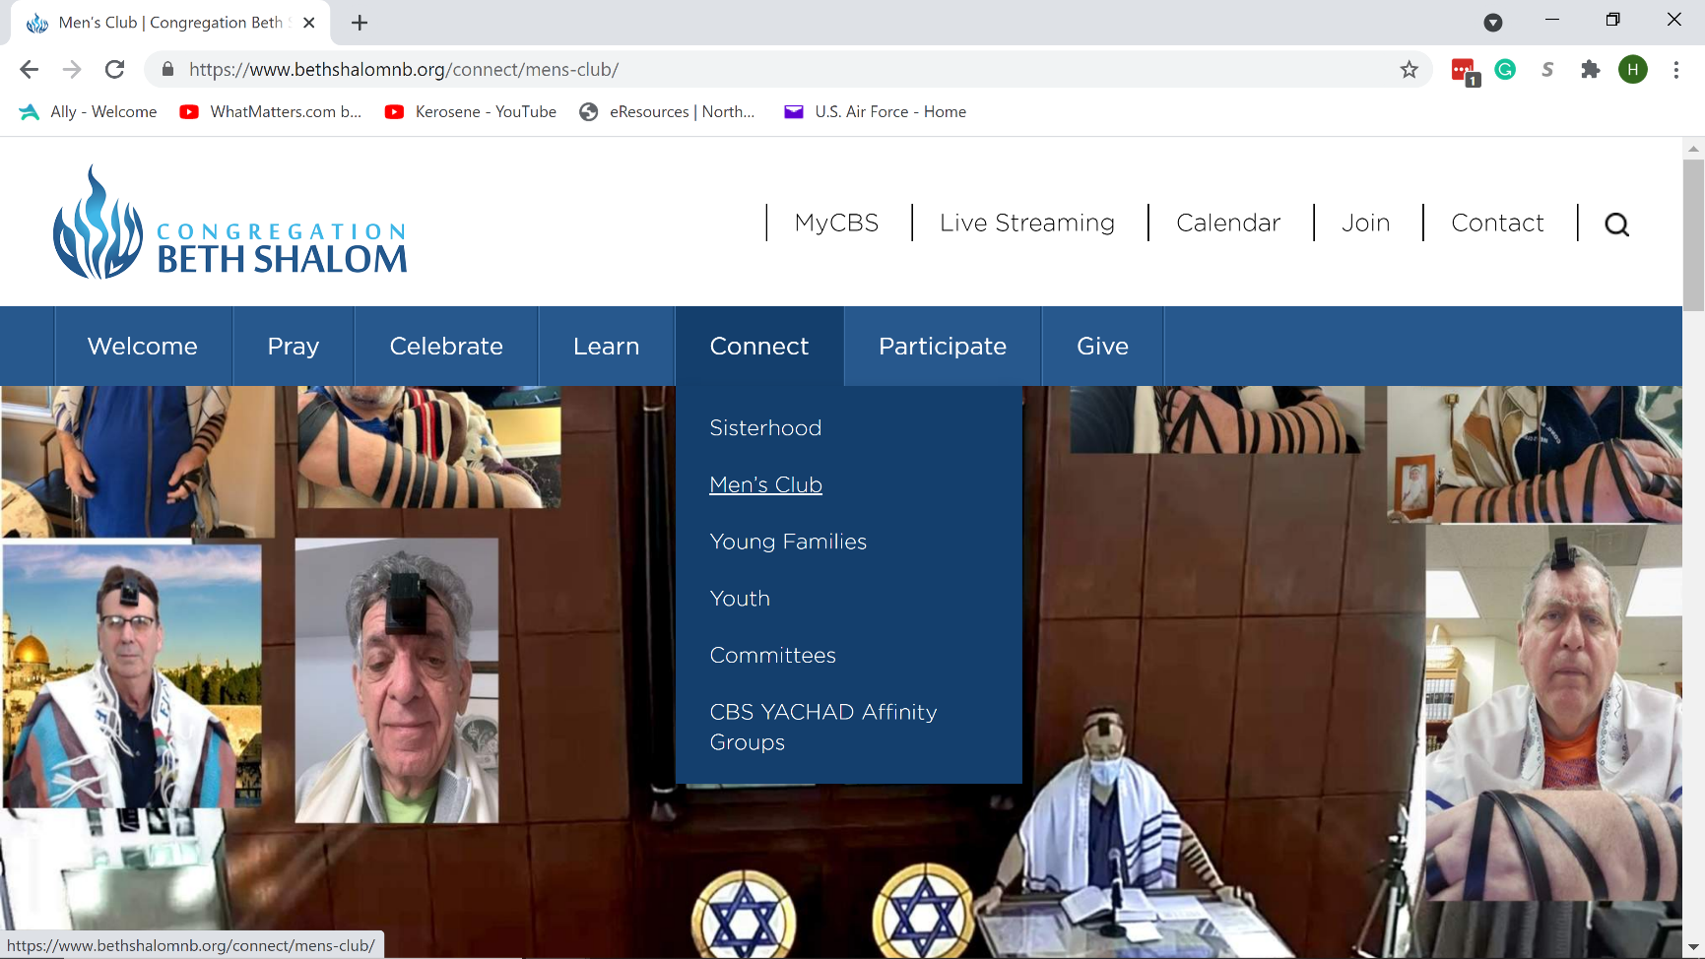

**Men’s Club Calendar Page and Left Navigation Bar**

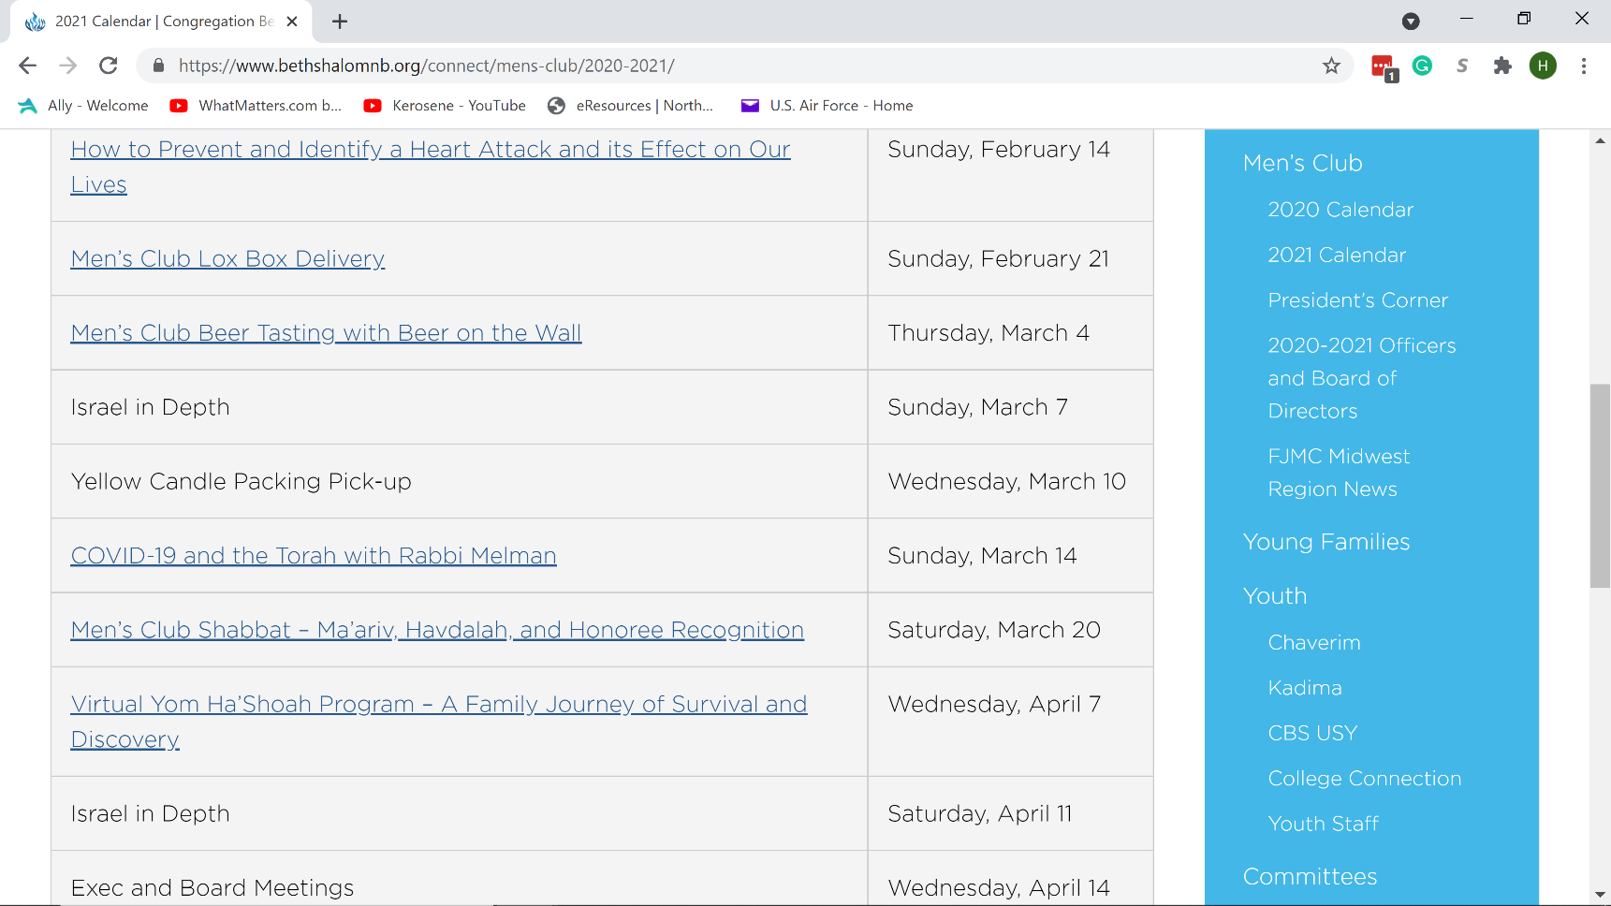

**Appendix B**

**Men’s Club Screenshots and Links**

**Men’s Club Event Registration and Payment Page**

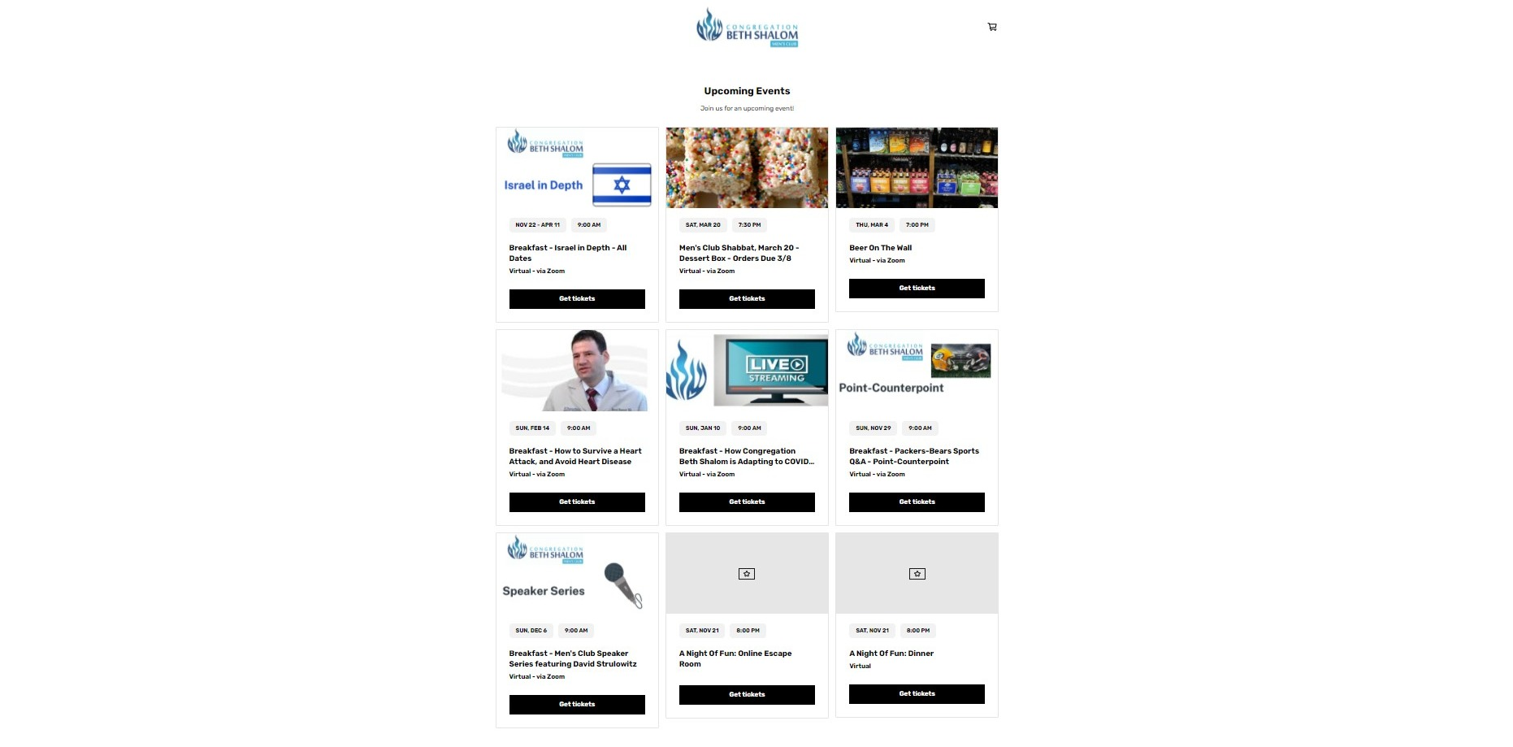

**Sample Website Links**

[**https://www.bethshalomnb.org/connect/mens-club/**](https://www.bethshalomnb.org/connect/mens-club/)

[**https://www.bethshalomnb.org/connect/mens-club/2020-calendar/**](https://www.bethshalomnb.org/connect/mens-club/2020-calendar/)

[**https://www.bethshalomnb.org/connect/mens-club/2020-2021/**](https://www.bethshalomnb.org/connect/mens-club/2020-2021/)

[**https://www.bethshalomnb.org/connect/mens-club/presidents-corner/**](https://www.bethshalomnb.org/connect/mens-club/presidents-corner/)