Brotherhood Weekend

No cost – All TBE members & guests invited

July 20-22

Award winning **Shabbat under the Stars** -Friday July 20 in courtyard at 8PM (*2nd Shabbat under the stars on Aug 24.) Parts available email Stan Marcus at* [*sdmarc1@aol.com*](mailto:sdmarc1@aol.com)

**Brotherhood Shabbat Service featuring FJMC traveling Sefer Haftorah Scroll** Saturday, July 21 9:30 AM

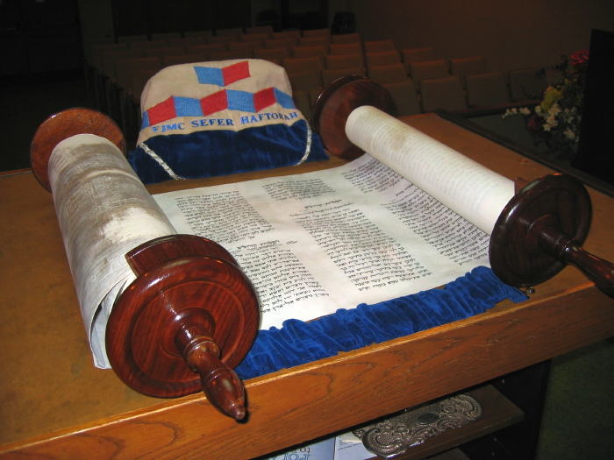

**Service honoring past Keepers of the Flame, Men of the Year and current Board of Directors.** Join us as we welcome Rabbi Ilana Foss to our Brotherhood and Congregation *(Kiddush Luncheon will follow service followed by lunch & learn with Rabbi Foss including Ice Cream Sundaes.)*

Tefillin Wrap followed by breakfast. Sunday, July 22. Meet at 9AM for instructions & help by experienced wrappers. Service at 9:30 followed by informal breakfast.

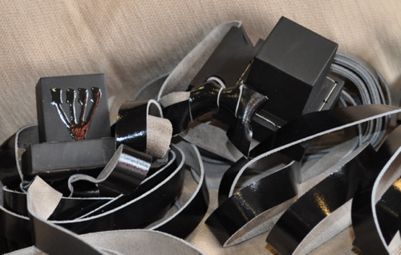

Please email [brotherhoodtbe@comcast.net](mailto:brotherhoodtbe@comcast.net) to be added to our email data base for future mailings.