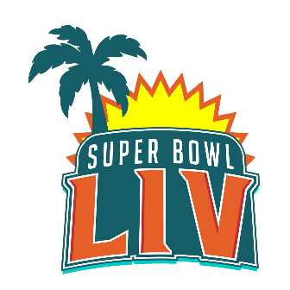Feed the Hungry Initiative

**Super Bowl LIV Party Time**

Sunday February 2nd, is Super Bowl Sunday and another reason to get together with friends and family, make 18 pounds of wings and other goodies to enjoy throughout the game. What do you do with the left overs you no longer want in your home? MJC Men’s Club along with Social Action have a plan. On Monday February 3rd, bring your leftovers to the Chai Building outside entrance from 9 AM – Noon and we will deliver all we collect to help feed the hungry throughout our area. We will have foil pans to receive your food if you do not have. Because your food may not be kosher, we will set up outside in the circle so we do not bring non kosher food inside the building, please do not bring food inside the Chai Building.

What types of foods should I bring?

* Chicken Wings
* Subs
* Pizza
* Chili
* Other Meats
* Snack foods

What not to bring?

* Dips and cream based items
* Cheeses & Dairy
* Any food that could potentially spoil or change while out in your home

If you can, please make some meals that can be placed in foil pans and frozen. Meals such as Chicken, Baked Ziti, Lasagna, Soups and more. It does not need to be Kosher, but can be if you prefer. Please write on the top of the foil pan the contents and freeze if possible. We can also have it frozen at the drop off center when we deliver later that day.

If you have questions or need more information, please call Alan Greenberg from Men’s Club at 732-861-8433 or email him at [GreenbergAlan@yahoo.com](mailto:GreenbergAlan@yahoo.com). If the hours for drop off do not work for your schedule, also let us know so we can potentially plan another drop off time.

