**2012 BROTHERHOOD SHABBATT**

**Brotherhood Shabbat Service featuring FJMC traveling Sefer Haftorah Scroll** Saturday, July 21 9:30 AM

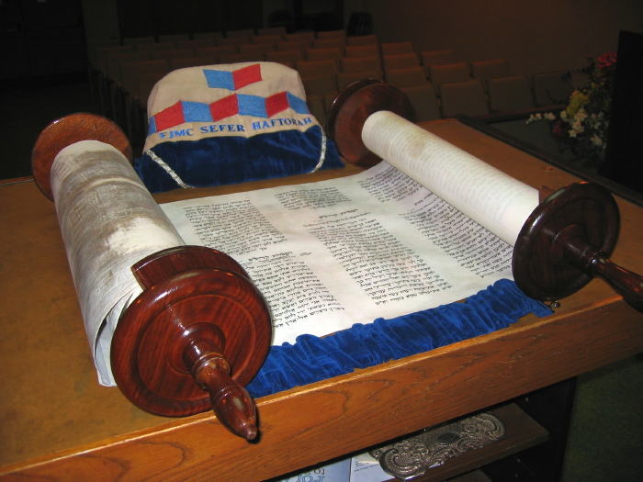

**Service honoring past Keepers of the Flame, Men of the Year and current Board of Directors.** We welcome Rabbi Ilana Foss to our Brotherhood and Congregation

*(Kiddush Luncheon will follow service followed by lunch & learn with Rabbi Foss)*