2019-2020 Calendar of Activities  September 6, 2019  Back to Shul BBQ  Once again we Man the grill to BBQ at Back to Shul night. A great evening, good food and fun and Shabbat as well.  September 8, 2019  Marlboro Day Sukkah Building  September 22, 2019  Rabbi Pont Holiday Training Camp  Join for breakfast in a one hour training camp for the upcoming High Holidays. Learn more, ask questions, and experience this exciting new program.  October 6, 2019  Sukkah Building  Help us to build the MJC Sukkahs at both the Main and Chai Buildings  October 16, 2019  Welcome Back BBQ – Hebrew High  BBQ for our High Hebrew High students.  October 17, 2019  15th Annual “Sports Bar in the Sukkah!”  Football and Baseball too! This is our annual Paid up Membership event, please make sure to join us. Food, drinks, football & good times. |  | Sunday October 27, 2019  Jewish Heritage Museum – Auschwitz exhibit  Sunday November 3 & 17, 2019  Volleyball in the Chai  Sunday December 8, 2019  Volleyball in the Chai  Sunday December 15, 2019  Hanukkah Party @ MJC  Latkes are our specialty as we prepare them for the kids at the Hanukkah party  Sunday December 15, 2019  Northern NJ Man of the Year Dinner  This year we are honoring our Man of the Year.  Saturday January 11, 2020  Pink & Teal Shabbat morning service  Sunday January 12, 2020  Volleyball in the Chai  Sunday January 19, 2020  NFL Playoffs Sports Bar  Food and good times watching the final game before the Super Bowl.  January 29, 2020  Build a Pair  We build Tefellin with our 6th graders  in preparation for World Wide Wrap |  | Sunday, February 2, 2020  “World Wide Wrap”  Join us and Jews from around the world on Super Bowl Sunday to wrap Tefillin and do this mitzvah.  Sunday February 9, 2020  Volleyball in the Chai  March 1, 2020  Build a Grogger  March 2020  Passover Wine & Candy Sale  March 9, 2020  “Pour”-im – our Award winning event  Purim is a lot more fun with members of  Men’s Club. Join for a pour of spirits as we hear the Magillah on Purim  Sunday March 15, 2020  Volleyball in the Chai  Friday, March 20, 2020  Men’s Club Shabbat – Shabbat loaded with spirit and Ruach!  Sunday, March 29, 2020  Yellow Candle Project – Yom HaShoah  Candle packing and delivery of the award winning Yellow Candle program to commemorate Yom Ha’Shoah  Watch the temple emails and publications for times, location, additions & changes to any programming.
MJC Men’s Club  2019-2020  Application  Name: _________________  Address: _______________  ______________________  Home Tel: _____________  Cell:__________________  E-mail:________________  Send this form and  $36 check payable to “MJC Men’s Club”  or by PayPal  Marlboro Jewish Center Men’s Club  103 School Road West  Marlboro, NJ 07746 | Show up for Shabbat – Saturday morning service. Please join Men’s Club on  October 12  December 7  December 21  January 11  February 1  March 14  May 16  May 30  June 27  Do you need some help around your home and don't know where to turn? Please contact us at Haimisha Helper since we are here and ready to lend a hand. If you have a small job such as replacing a light bulb, changing dead batteries, moving your patio furniture, schlepping boxes to the curb or some other need, MJC Men's Club is at the ready. We have a minyan of Men who want to help to make your life easier. Whether your need is short term or long, we are just a phone call away. Please call Alan Greenberg at 732-861-8433 or email to MJCNJMC@gmail.com. This is a free service provided by MJC Men's Club. |  | 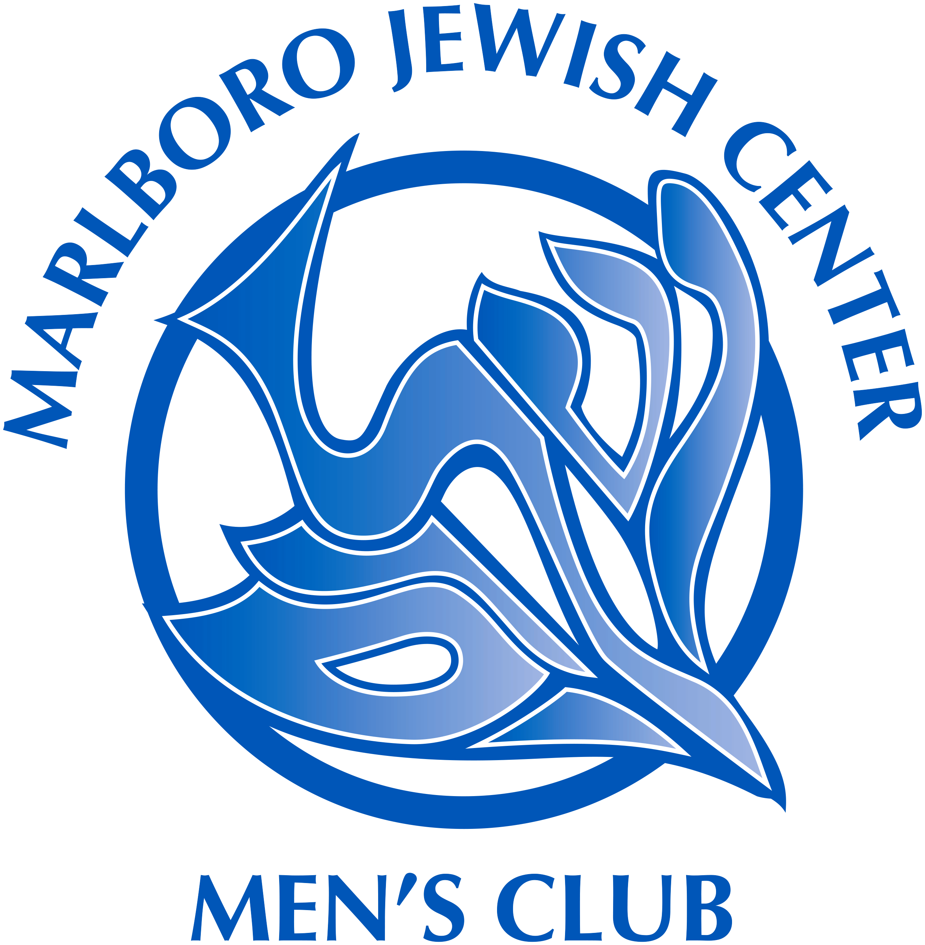  2019-2020 Schedule and Enrollment Form  Open to all men  Affiliated with  Federation of Jewish Men’s Clubs  A social and service arm of  Marlboro Jewish Center  2019/2020 President:  Alan Greenberg  732-861-8433  MJCNJMC@gmail.com

