BETH EL TEMPLE
MEN’S CLUB BREAKFAST

Date: Sunday, March 7, 2010

Yom HaShoah Candle Packaging

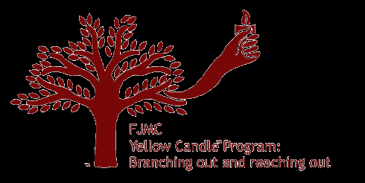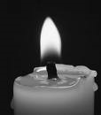

Yom HaZikaron laShoah ve-laGvura (יום הזיכרון לשואה ולגבורה; "Remembrance Day for the Holocaust and Heroism"), known as Yom HaShoah or as Holocaust Remembrance Day, is observed as a day of commemoration for the approximately six million Jews who perished in the Holocaust. In Israel, it is a national memorial day. Candles are lit the evening of Sunday, April 11th.

Please help us as we prepare for mailing nearly 1,000 yellow candles to Beth El members.

Place: Beth El Temple

Time: 8:45 Morning Minyan
9:15 Breakfast Buffet
10:00 Yom HaShoah Candle Packaging

Cost: Free for all participants and Men’s Club members
$7 all others

RSVP: Phil Schulz at 651-0072 / philschulz@sbcglobal.net by Mar. 4.

