The Story Behind the Story of Our Roots Logo
"More than any other medium, photography has the power
to give expression to the ...... value of a deed." - Jakob Rosner
These words were written by and set a standard for the photojournalism of Jakob Rosner, a Jewish photographer who fled Munich in the 1930s. While ashes of the Shoah smoldered in Europe, Rosner put his camera to work in Palestine for Keren Kayemeth LeIsrael (KKL, the Jewish National Fund). His assignment: give expression to the need, then more compelling than ever, to re-establish an independent homeland. His iconic photo, "Child with KKL Collection Box", c. 1945 captured the intense focus at the time of virtually all Jews - halutzim, the Diaspora, and ‘sherit plaitah, the surviving remnant - for ending their two thousand year legacy of expulsion, dispersion, wandering and persecution.
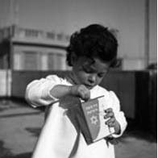
Child with Collection Box
Inspired by the story of Jakob Rosner's journey and the power of expression conveyed in his famous image, Brotherhood's Roots Committee patterned its logo to also feature a ‘child with collection box'. As in the original, our poster child tenderly offers a coin for Israel.
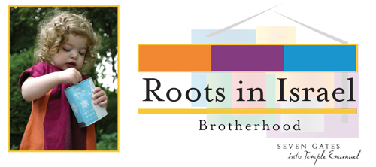
The objective of Brotherhood's Roots program is strengthening our community's connection and bond with Israel. We believe the ‘story behind the story' makes our logo/image well suited to the mission.
Jakob Rosner's life was sadly cut short in 1950, but he lived long enough to witness the powerful expression of the deed he worked to document, the declaration establishing an independent State of Israel.

