**War Years**

* http://accountsoftheholocaust.org/accountsoftheholocaust/media/Avatars/robert-katz.jpg?ext=.jpgROBERT KATZ

September 1, 1939

*I read in the newspaper that Germany invaded Poland! My thoughts today are with all of you that I have met on this group. Please let me know how you are?*  
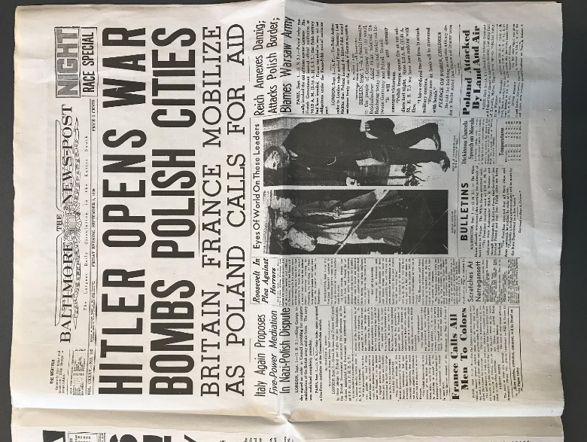

http://accountsoftheholocaust.org/accountsoftheholocaust/media/Avatars/female-icon.png?ext=.pngHALINKA STREZGOWSKI (Sosnoweic, Poland)

We all had a reason to pray right now. The terrible war that I wanted desperately to forget was at our doorstep. A small troop of Nazi soldiers, had spent the better part of two weeks closing Jewish owned stores and businesses.

http://accountsoftheholocaust.org/accountsoftheholocaust/media/Avatars/female-icon.png?ext=.pngHALINKA STREZGOWSKI (Sosnoweic, Poland)

The four Nazi's that had pushed their way into our house, looked nasty. They looked at Papa with such contempt, it broke my heart. I wanted to wipe the nasty curl from their lips. I wanted to punch them right in those narrowed eyes.

* http://accountsoftheholocaust.org/accountsoftheholocaust/media/Avatars/robert-katz.jpg?ext=.jpgROBERT KATZ

September 10, 1939

*I haven’t heard anything from this group and I am starting to get worried…*

http://accountsoftheholocaust.org/accountsoftheholocaust/media/Avatars/estelle-laughlin.png?ext=.pngESTELLE LAUGHLIN (10 years old. Warsaw, Poland)

They immediately closed schools. They made books illegal. They rationed all food. They stopped the electric power. We have no telephones, can’t reach anyone, even in case of an emergency. We have no newspapers.

http://accountsoftheholocaust.org/accountsoftheholocaust/media/Avatars/ruth-cardin.jpg?ext=.jpgRUTH CARDIN

*You wont hear from anyone in Germany or Poland – not now that Hitler has invaded. Luckily for us living in France he appears to be looking in the other direction. For now…*

http://accountsoftheholocaust.org/accountsoftheholocaust/media/Avatars/robert-katz.jpg?ext=.jpgROBERT KATZ

**Estelle Laughlin** – are you safe? How do you know if your friends and family are safe?

http://accountsoftheholocaust.org/accountsoftheholocaust/media/Avatars/robert-katz.jpg?ext=.jpgROBERT KATZ

**Estelle**?

http://accountsoftheholocaust.org/accountsoftheholocaust/media/Avatars/robert-katz.jpg?ext=.jpgROBERT KATZ

 Anna, how is life for you in Berlin now that Hitler has declared war on Poland?

http://accountsoftheholocaust.org/accountsoftheholocaust/media/Avatars/robert-katz.jpg?ext=.jpgROBERT KATZ

**Anna Liebener?**

http://accountsoftheholocaust.org/accountsoftheholocaust/media/Avatars/robert-katz.jpg?ext=.jpgROBERT KATZ

*But surely there is some way of getting news? What about those who managed to leave before the war – do you hear from your families back home?*

http://accountsoftheholocaust.org/accountsoftheholocaust/media/Avatars/trude-silman.jpg?ext=.jpgTRUDE SILMAN (England)

People don’t realize… that letters are very irregular even if you write regularly, and they can take six to seven months to reach you.

http://accountsoftheholocaust.org/accountsoftheholocaust/media/Avatars/gita-rossi-zalman.jpg?ext=.jpgGITTA ROSSI-ZALMONS (England)

My mother wrote to us, she was very relieved to hear we were at a decent school and my father, in the mean time, was released from Dachau and he was delighted to hear that we had been sent away.

http://accountsoftheholocaust.org/accountsoftheholocaust/media/Avatars/trude-silman.jpg?ext=.jpgTRUDE SILMAN (England)

 We do have the radio on and we use it to listen to the news and every night at 9 o’clock they play all the national anthems of the Allies. We always listen to that and we are made aware of what is happening…

http://accountsoftheholocaust.org/accountsoftheholocaust/media/Avatars/robert-katz.jpg?ext=.jpgROBERT KATZ

*And what about those who are still trying to leave? Is it even possible now with the outbreak of war?*

http://accountsoftheholocaust.org/accountsoftheholocaust/media/Avatars/rudalf-schwab.jpg?ext=.jpgRUDALF SCHWAB

Ever since I have been here [South Africa], I have begged my parents to try and come out, while there was still a reasonable chance, but my father held too optimistic a view about the whole situation and so missed the famous last boat. I have still not given up hope that a chance might turn up soon. In the meantime, we can only wait and hope for the best.

* BBC Broadcasting to the World from London

January 12, 1940

**A broadcast to neutral nations, Churchill:**  
“Let the great cities of Warsaw, of Prague, of Vienna, banish despair even in the midst of their agony. Their liberation is sure!”

* http://accountsoftheholocaust.org/accountsoftheholocaust/media/Avatars/robert-katz.jpg?ext=.jpgROBERT KATZ

February 1941

Why are so few people commenting and posting on this group?

http://accountsoftheholocaust.org/accountsoftheholocaust/media/Avatars/ruth-cardin.jpg?ext=.jpgRUTH CARDIN

*People are terrified; they have been removed from their homes, their belongings, some are in hiding or running for their lives! They don’t have the access or opportunity for a page like this. At least that is what I hope for when I don’t hear from my friends…*

http://accountsoftheholocaust.org/accountsoftheholocaust/media/Avatars/robert-katz.jpg?ext=.jpgROBERT KATZ

*But there must be others like* ***Rudalf Schwab*** *who is in South Africa? Did other people manage to leave before the war and are living in exotic/different places? Maybe you can tell us how you are coping?*

http://accountsoftheholocaust.org/accountsoftheholocaust/media/Avatars/Liselotte-laub.jpg?ext=.jpgLiselotte Laub (Israel)

Immigration is a very difficult thing, to come to another country without speaking the language. I, as a child, am just nothing, I have no relatives, no language, nothing that belongs to me – it was all lost.

http://accountsoftheholocaust.org/accountsoftheholocaust/media/Avatars/doris-lurie.jpg?ext=.jpgDoris Lurie (Durban 13 years old)

 South Africa is like a breath of fresh air; the colours and the Zulus and the Rickshaws and to be near the sea and the palm trees. It is a completely different scene to Europe.

http://accountsoftheholocaust.org/accountsoftheholocaust/media/Avatars/erwin-sensel.jpg?ext=.jpgErwin Sensel (Caracas, Venezuela)

From the land where we were despised, we came to a land were we were respected

http://accountsoftheholocaust.org/accountsoftheholocaust/media/Avatars/robert-katz.jpg?ext=.jpgROBERT KATZ

*Do you miss home?*

http://accountsoftheholocaust.org/accountsoftheholocaust/media/Avatars/doris-lurie.jpg?ext=.jpgDoris Lurie

I am very nostalgic; not only remembering Austria but also remembering Europe.

* BBC NEWS

December 7th 1941

**The attack on Pearl Harbour and the Japanese declaration of war.**  
“Japan’s long threatened aggression in the Far East began tonight with air attacks of United States naval bases in the Pacific.”

* http://accountsoftheholocaust.org/accountsoftheholocaust/media/Avatars/robert-katz.jpg?ext=.jpgROBERT KATZ

*So few people have checked in?*

RUTH CARDIN

*People are terrified; they have been removed from their homes, their belongings, some are in hiding or running for their lives! They don’t have the access or opportunity for a page like this. At least that is what I hope for when I don’t hear from my friends…*

http://accountsoftheholocaust.org/accountsoftheholocaust/media/Avatars/robert-katz.jpg?ext=.jpgROBERT KATZ

*Just checking in with those around the world. Have you managed to be reunited with your loved ones?*

http://accountsoftheholocaust.org/accountsoftheholocaust/media/Avatars/erwin-sensel.jpg?ext=.jpgErwin Sensel (Caracas, Venezuela)

After two years, in 1941, my wife came over. She travelled from Vienna, via Berlin and Moscow to Japan. In Tokyo she received her visa for Venezuela, which I had organised. She went on to Honolulu, San Francisco, New York and from New York, by boat to La Guaira and Caracas.

http://accountsoftheholocaust.org/accountsoftheholocaust/media/Avatars/robert-katz.jpg?ext=.jpgROBERT KATZ

*And your parents? Have they joined you?*

http://accountsoftheholocaust.org/accountsoftheholocaust/media/Avatars/erwin-sensel.jpg?ext=.jpgErwin Sensel (Caracas, Venezuela)

Visas were granted for thirty parental couples but none of them ever arrived. They were not allowed to leave, the authorities preferred to have them killed

* http://accountsoftheholocaust.org/accountsoftheholocaust/media/Avatars/robert-katz.jpg?ext=.jpgROBERT KATZ

June 25, 1942

*There is a report in the Daily Telegraph today claiming “700,000 Polish Jews have been slaughtered” in the “greatest massacre in the world’s history”! But it is only on the 5th page of a 6-page publication – are people not taking this seriously?*

http://accountsoftheholocaust.org/accountsoftheholocaust/media/Avatars/heinrich-himmler.jpg?ext=.jpgHEINRICH HIMMLER

 I myself hate this bloody business and I have been moved to the depths of my soul. But I am obeying the highest law by doing my duty. Man must defend himself against bedbugs and rats – against vermin.

* **** Heinrich Himmler has been permanently blocked from this group***
* http://accountsoftheholocaust.org/accountsoftheholocaust/media/Avatars/ruth-cardin.jpg?ext=.jpgRUTH CARDIN

August 1943

*I heard that* ***Jan Karski****, a spy for the Polish government in exile, was actually smuggled into the* [*Warsaw Ghetto*](https://encyclopedia.ushmm.org/content/en/article/warsaw-ghetto-uprising)*. He has visited London and even spoke to President Roosevelt while in America. Maybe he can tell us what he saw?*

http://accountsoftheholocaust.org/accountsoftheholocaust/media/Avatars/jan-karski.jpg?ext=.jpgJAN KARSKI

Well so now comes the description… naked bodies on the street. I asked him why are they here – corpses. He says “well, they have a problem. If a Jew dies and the family wants some burial,  they have to pay tax on it. So they just throw them in the street… They cannot afford it. So then they say: “every rag counts” so they take their clothing… Women with their babies; publicly feeding their babies. They have no breast, its just flat… The streets full, full. Apparently all of them lived in the street… Everybody offering something to sell: three onions, buy onions some cookies, selling, begging each other, crying, hungry… It wasn't humanity, it was some, some hell.

http://accountsoftheholocaust.org/accountsoftheholocaust/media/Avatars/robert-katz.jpg?ext=.jpgROBERT KATZ

*But why is no-one listening to you? Why aren’t people taking this more seriously?*

http://accountsoftheholocaust.org/accountsoftheholocaust/media/Avatars/jan-karski.jpg?ext=.jpgJAN KARSKI

They will think I exaggerate or invent. But I saw it and it is not exaggerated or invented. I have no proof, no photographs. All I can say is that I saw it, and it is the truth.

http://accountsoftheholocaust.org/accountsoftheholocaust/media/Avatars/US-supreme-court-justice-felix-frankfurter.jpg?ext=.jpgU.S. SUPREME COURT JUSTICE FELIX FRANKFURTER:

I do not believe you

http://accountsoftheholocaust.org/accountsoftheholocaust/media/Avatars/robert-katz.jpg?ext=.jpgROBERT KATZ

*How can you say that he is lying?*

http://accountsoftheholocaust.org/accountsoftheholocaust/media/Avatars/US-supreme-court-justice-felix-frankfurter.jpg?ext=.jpgU.S. SUPREME COURT JUSTICE FELIX FRANKFURTER:

 I did not say that he is lying; I said that I don’t believe him

http://accountsoftheholocaust.org/accountsoftheholocaust/media/Avatars/robert-katz.jpg?ext=.jpgROBERT KATZ

*I think I know what you mean – what* ***Jan Karski*** *has described here just sounds to horrific to understand or even grasp…*

* http://accountsoftheholocaust.org/accountsoftheholocaust/media/Avatars/robert-katz.jpg?ext=.jpgROBERT KATZ

June 6, 1944

*Does this headline signal the beginning of the end?*  
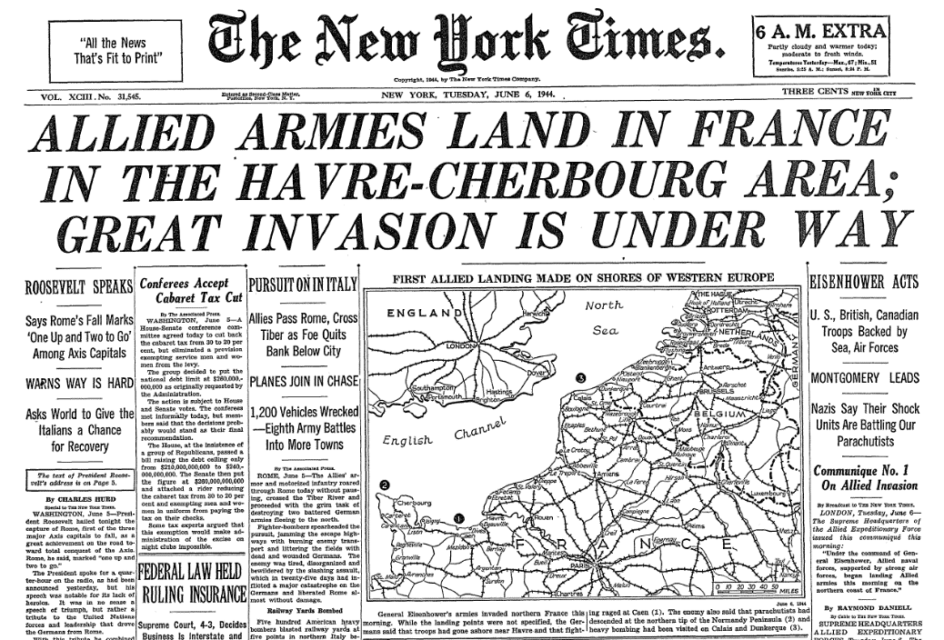

* http://accountsoftheholocaust.org/accountsoftheholocaust/media/Avatars/robert-katz.jpg?ext=.jpgROBERT KATZ

***Gitta Rossi-Zalmans****, have you had any more letters from your mother? Do you have any more news?*

http://accountsoftheholocaust.org/accountsoftheholocaust/media/Avatars/gita-rossi-zalman.jpg?ext=.jpgGITTA ROSSI-ZALMONS (England)

I’ve got a card from my mother where she says:”We’re being transported tomorrow”… She wrote she hears [Theresienstadt](https://encyclopedia.ushmm.org/content/en/article/theresienstadt) is not one of the worst camps and we mustn’t give up hope, they will see us again.****

http://accountsoftheholocaust.org/accountsoftheholocaust/media/Avatars/robert-katz.jpg?ext=.jpgROBERT KATZ

*That sounds positive! The photo I posted above, was taken during an inspection of Theresienstadt by the International Red Cross. It doesn’t look like people are too badly off there – I hope you and many others hear good news from your families.*